**Question 1: Find out the mail servers of the following domains: ibm.com, wipro.com**

**Solution:** Open Terminal.

**For ibm.com -**

Type the command **nslookup**

**set type=mx**

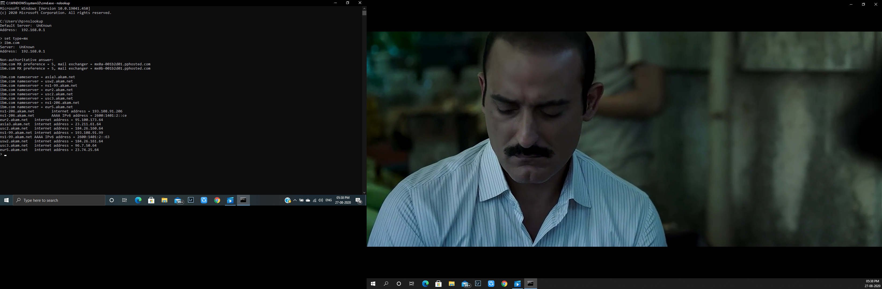**ibm.com**

**For wipro.com -**

Type the command **nslookup**

**set type=mx**

**wipro.com**

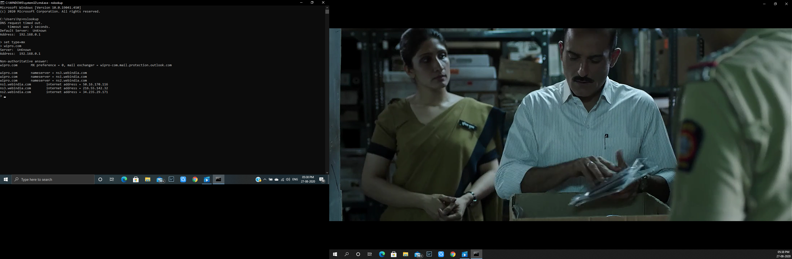

**Question 2: Find the locations, where these email servers are hosted.**

**Solution:**

**Mail server locations for ibm.com are :-**

1. **mx0a-001b2d01.pphosted.com**

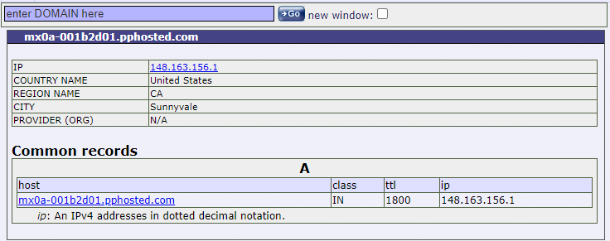

1. **mx0a-001b2d01.pphosted.com**

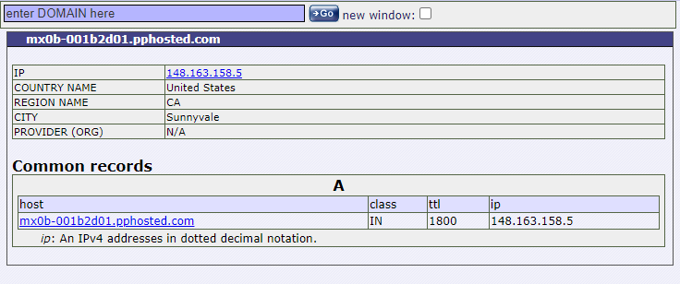

**Mail server location for wipro.com is :-**

**wipro-com.mail.protection.outlook.com**

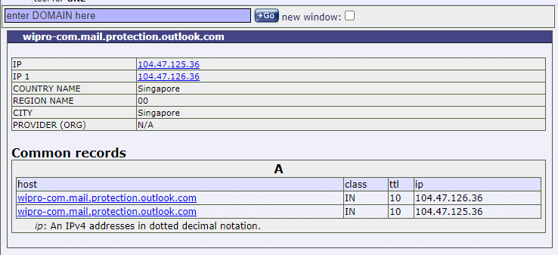

**Question 3: Scan and find out port numbers open 203.163.246.23**

**Solution:** The given IP was scanned using NMAP

Command: nmap 203.163.246.23

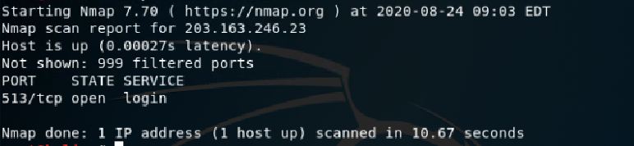

**Question 4: Install Nessus in a VM and scan your laptop/desktop for CVE.**

**Solution:**

1. Install Nessus in your virtual machine open it .
2. Click on new scan.
3. Then click on advance scan.
4. Now, fill name description and target ip which is 192.168.1.101 in this case.

And then click on scan.

